Test Case: tc001_SPX_Dev5_Crear_Requisicion_Spot_Tipo_Cobro_CC
Step 1 - Enter username and password and click to button Enter : Credentials Entered
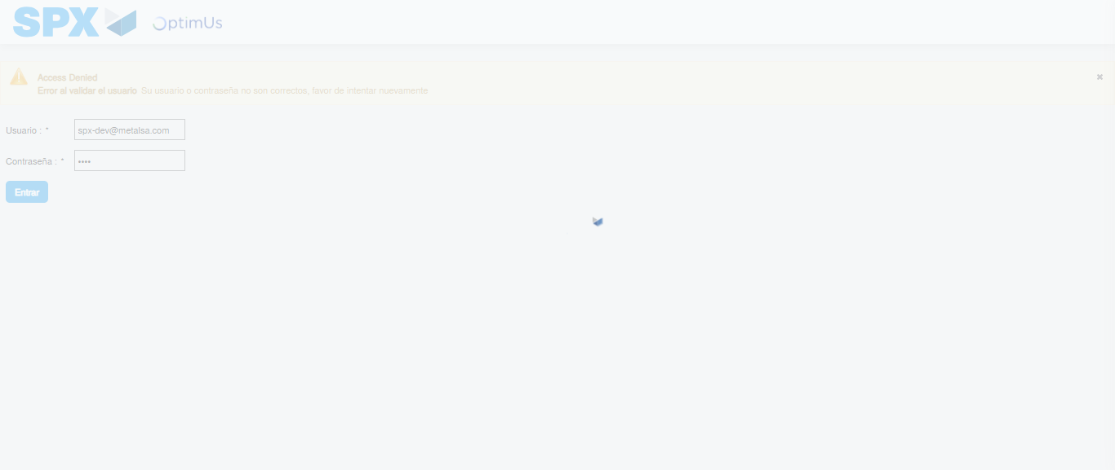Image file-name: QC_Testing-tc001_SPX_Dev5_Crear_Requisicion_Spot_Tipo_Cobro_CC-1782255657216

Step 2 - Select to UEN and Access to Spot Buy Requisitions : UEN Correctly selected and Correct access
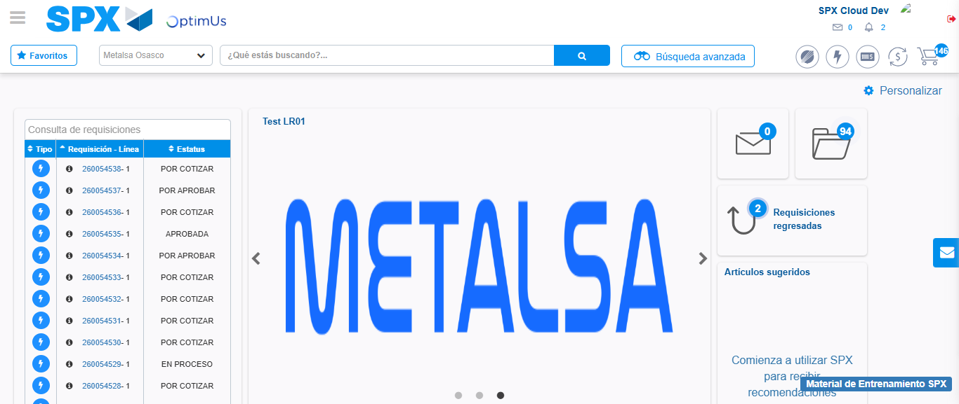Image file-name: QC_Testing-tc001_SPX_Dev5_Crear_Requisicion_Spot_Tipo_Cobro_CC-1782255726204

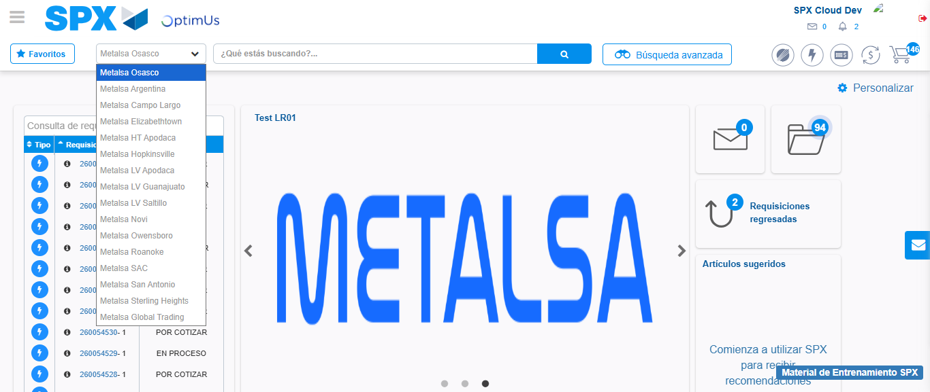Image file-name: QC_Testing-tc001_SPX_Dev5_Crear_Requisicion_Spot_Tipo_Cobro_CC-1782255728936

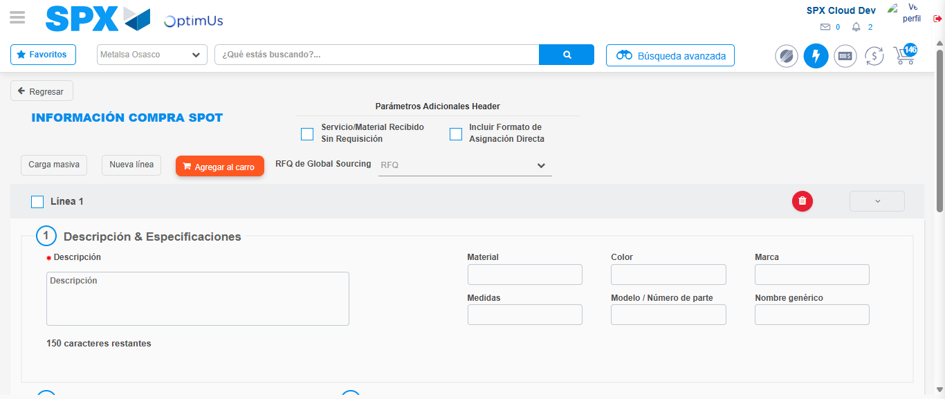Image file-name: QC_Testing-tc001_SPX_Dev5_Crear_Requisicion_Spot_Tipo_Cobro_CC-1782255739415

Step 3 - Data Capture Spot Buy Requisition : Data captured correctly
Image file-name: QC_Testing-tc001_SPX_Dev5_Crear_Requisicion_Spot_Tipo_Cobro_CC-1782255739686

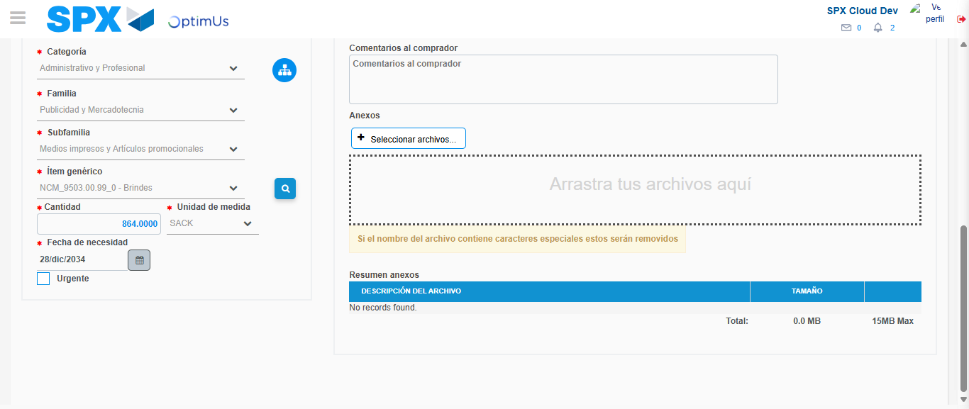Image file-name: QC_Testing-tc001_SPX_Dev5_Crear_Requisicion_Spot_Tipo_Cobro_CC-1782255752485

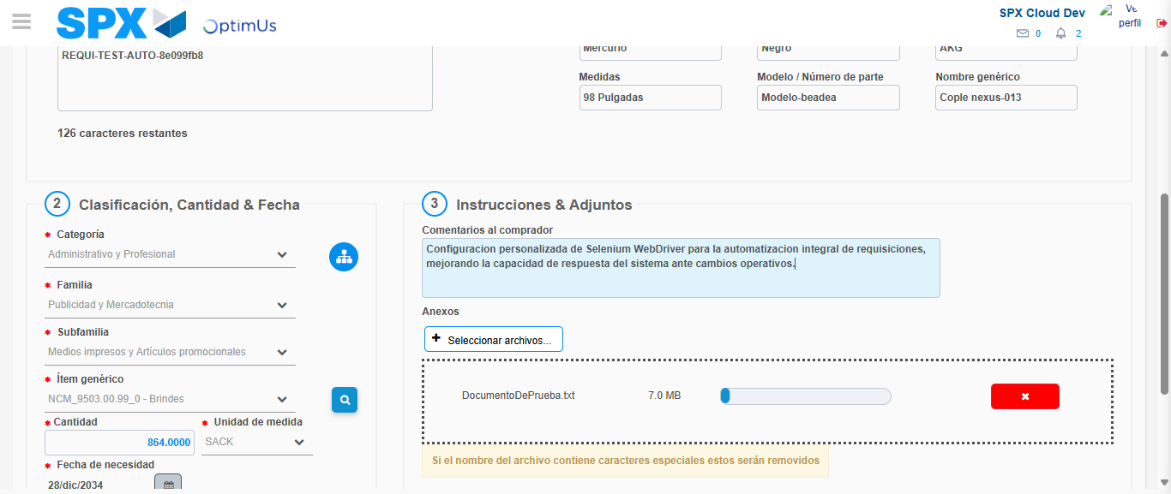Image file-name: QC_Testing-tc001_SPX_Dev5_Crear_Requisicion_Spot_Tipo_Cobro_CC-1782255753416

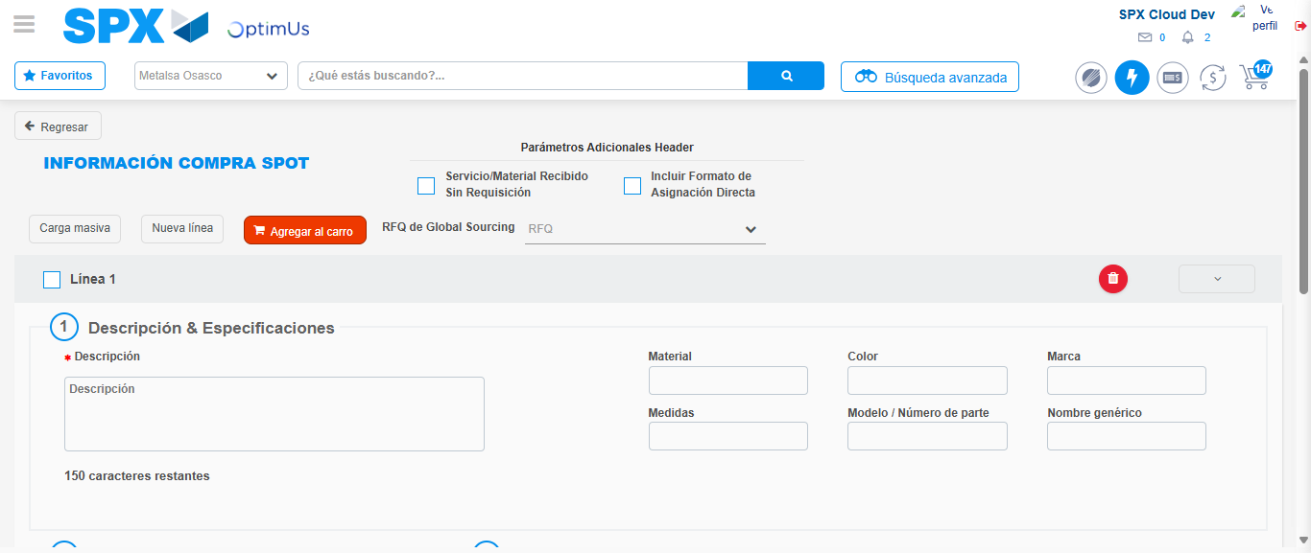Image file-name: QC_Testing-tc001_SPX_Dev5_Crear_Requisicion_Spot_Tipo_Cobro_CC-1782255758317

Step 7 - Return to Main Page SPX : Return to Main Page SPX
Image file-name: QC_Testing-tc001_SPX_Dev5_Crear_Requisicion_Spot_Tipo_Cobro_CC-1782255726204

Image file-name: QC_Testing-tc001_SPX_Dev5_Crear_Requisicion_Spot_Tipo_Cobro_CC-1782255728936

Image file-name: QC_Testing-tc001_SPX_Dev5_Crear_Requisicion_Spot_Tipo_Cobro_CC-1782255739415

Image file-name: QC_Testing-tc001_SPX_Dev5_Crear_Requisicion_Spot_Tipo_Cobro_CC-1782255760587

Image file-name: QC_Testing-tc001_SPX_Dev5_Crear_Requisicion_Spot_Tipo_Cobro_CC-1782255760777

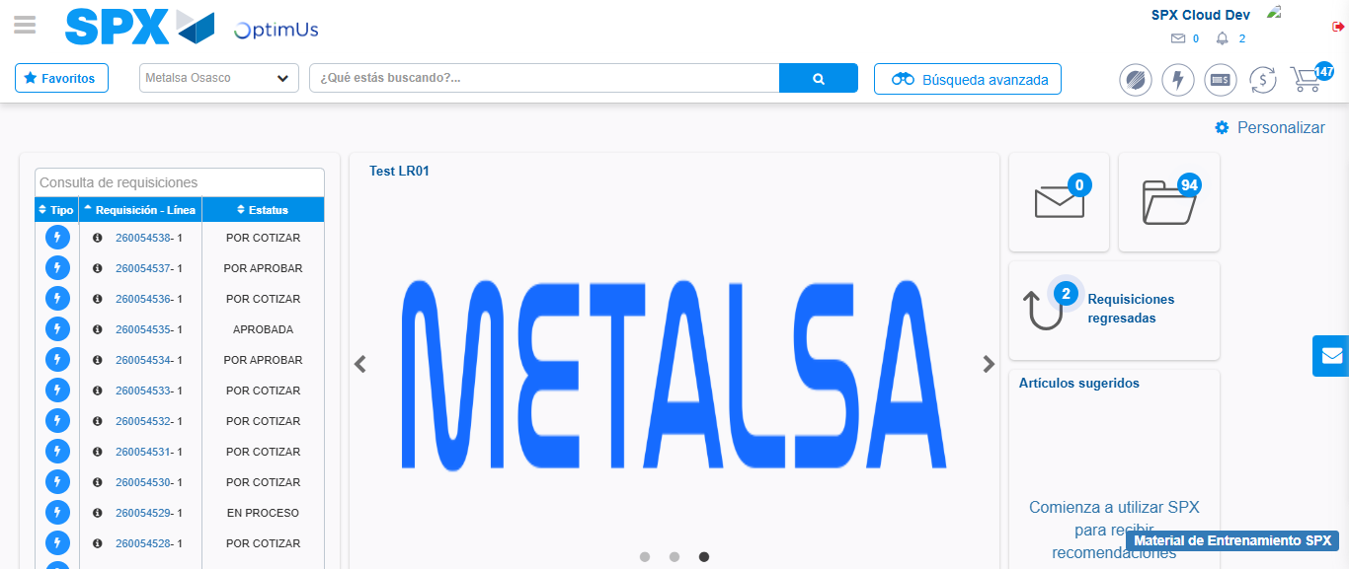Image file-name: QC_Testing-tc001_SPX_Dev5_Crear_Requisicion_Spot_Tipo_Cobro_CC-1782255782280

Step 8 - Log Out : Log Out SPX
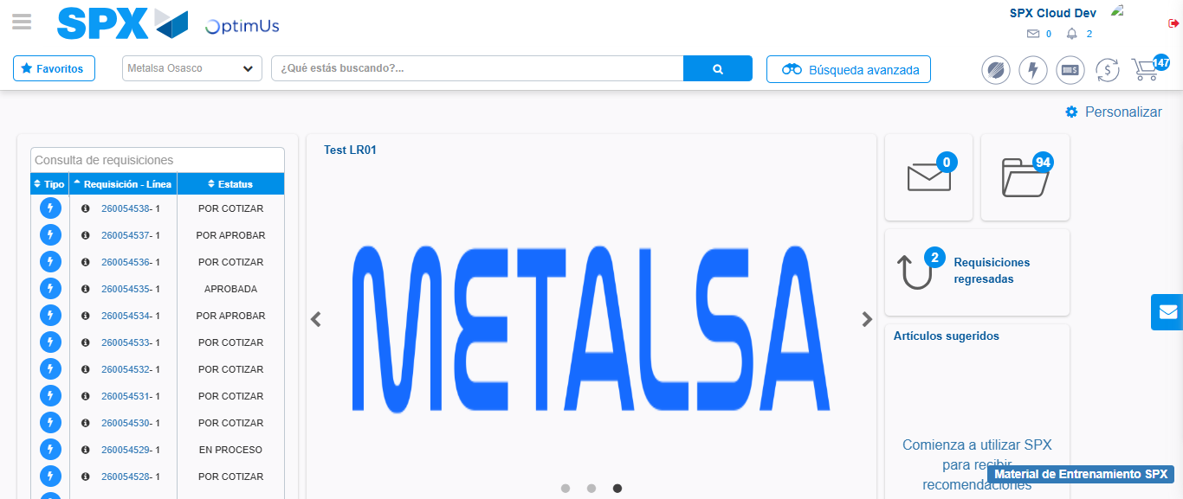Image file-name: QC_Testing-tc001_SPX_Dev5_Crear_Requisicion_Spot_Tipo_Cobro_CC-1782255782631

